**Experiment Number: 03**

Problem Statement: **shell scripting program.**

NAME : **Manomay Jamble**  ROLL NO: **49**

CLASS: **TY**(**AI&DS**) BATCH: **3**

DATE OF PERFORMANCE: **11-09-2022**

______________________________________________________________

**PROGARM**:

**shell scripting programs.**

______________________________________________________________

**OUTPUT:**

**1.Write a shell program to print given number in reverse order**

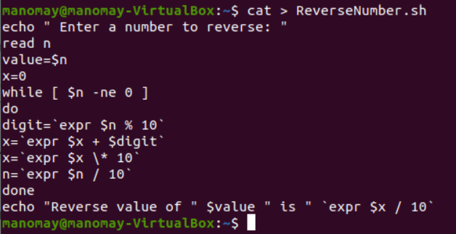

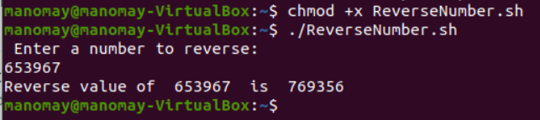

**2. write a shell program to perform arithmetic operations uisng case**

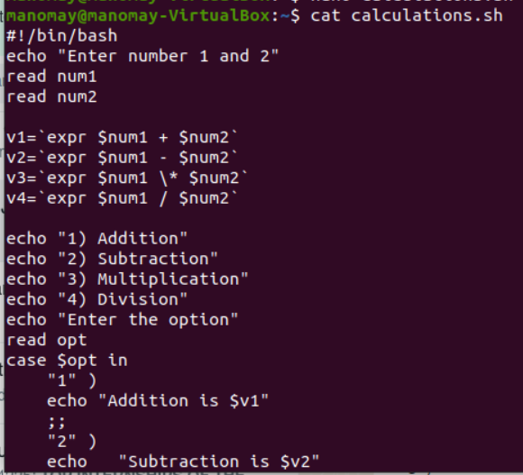

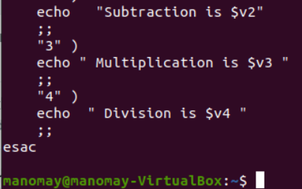

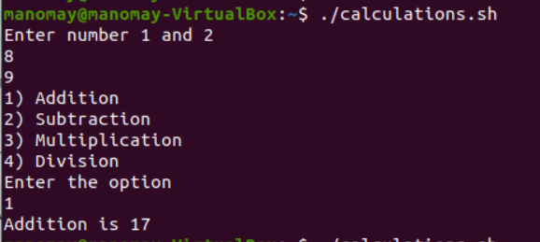

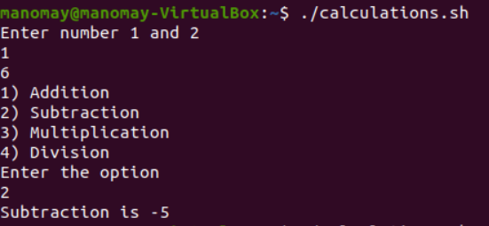

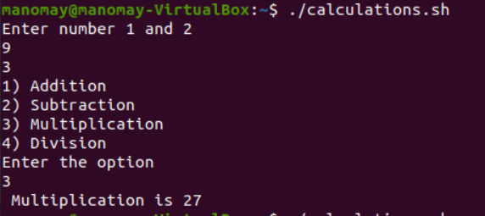

**3. Write a  shell script to check file type and permissions of a given input by user**

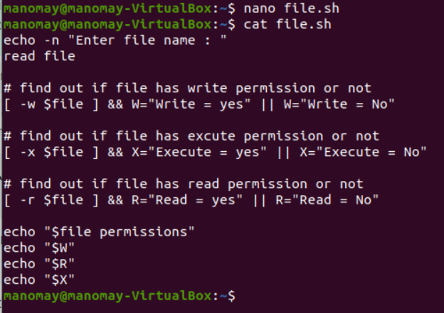

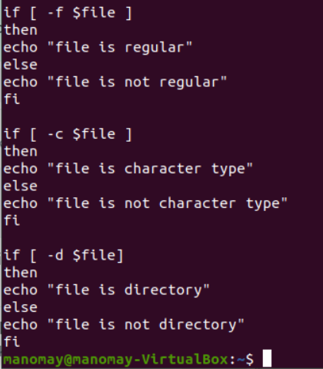

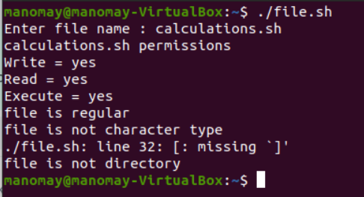

**4. Write a shell script to Find factorial of a given number using function**

**1. Without Recursion**

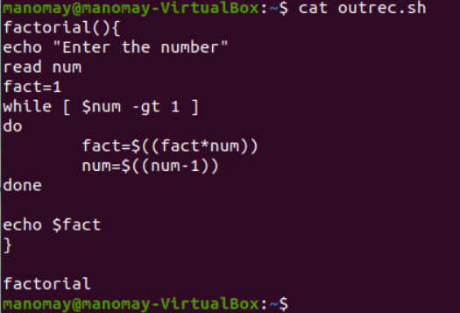

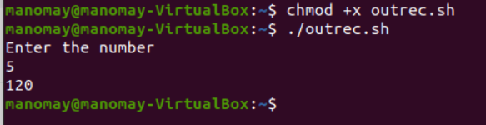

**2. With Recursion**

